Figure 1
811 South Buffalo Street Warsaw, Indiana 46580

2020
Community Assessment
Meeting the Needs of Families through our Community

Kosciusko County Head Start

Table of Contents:

Preface………………………………………………………………………………………………………………………………………………. 1
Methodology…………………………………………………………………………………………………………………………………..... 1
Introduction………………………………………………………………………………………………………………………………………. 2
Kosciusko County Demographics……………………………………………………………………………………………………….. 3
Townships……………………………………………………………………………………………………………………..………….. 5
Major Cities and Towns……………………………………………………………………………………………………………… 7
Overview of Economic Trends…………………………………………………………………………………………………… 8
Income………………………………………………………………………………………………………………………………………. 9
Unemployment Rates……………………………………………………………………………………………………………… 10
Race and Ethnicity…………………………………………………………………………………………………………………… 10
Public Assistance Data…………………………………………………………………………………………………………….. 12
Homelessness………………………………………………………………………………………………………………………….. 14
Poverty Rate and Food Insecurity……………………………………………………………………………………………. 15
Transportation………………………………………………………………………………………………………………………… 15
Housing…………………………………………………………………………………………………………………………………… 16
Other Child Care Programs in Kosciusko County………………………………………………………………………………. 17
Services for Young Children with Disabilities……………………………………………………………………………………. 19
Education, Health, Nutrition, and Social Services……………………………………………………………………………… 20
Education: Kosciusko County Schools………………………………………………………………………………………. 20
Health and Nutrition……………………………………………………………………………………………………………….. 23
General Health Issues…………………………………………………………………………………………………. 23
Maternal and Infant Health Care and Nutrition………………………………………………………….. 24
Mental Health…………………………………………………………………………………………………………….. 27
Dental Health……………………………………………………………………………………………………………… 27
Social Services……………………………………………………………………………………………………………............... 28
Child Abuse and Neglect……………………………………………………………………………………………… 28
Foster Care…………………………………………………………………………………………………………………. 28
Domestic Violence: The Beaman Home………………………………………………………………………. 29
Meth Lab Seizures………………………………………………………………………………………………………. 30
Kosciusko County Jail Bookings…………………………………………………………………………………… 30
Head Start and Early Head Start Children and Families……………………………………………………………………. 31
Introduction and Demographics……………………………………………………………………………………………… 31
Race and Ethnicity…………………………………………………………………………………………………………………… 32
Education………………………………………………………………………………………………………………………………… 32
Children with Disabilities…………………………………………………………………………………………………………. 33
Health and Nutrition…………………………………………………………………………………………………………........ 33
Social Services…………………………………………………………………………………………………………………………. 34
Resources in the Community…………………………………………………………………………………………………………… 35
Bibliography……………………………………………………………………………………………………………………………………. 35

Preface
Head Start Program Performance Standard, 45 CFR Part 1302.11 states each program must conduct a Community Assessment at least once over the five-year grant period to assure the design of a program meets community needs and builds on strengths and resources. The standard also states the program must annually review and update the Community Assessment to reflect any significant changes including increased availability of public-funded pre-kindergarten, rates of family and child homelessness, and significant shifts in community demographics and resources. The data must include, at a minimum, the number of eligible infants, toddlers, preschool age children, and expectant mothers, including their geographic location, race, ethnicity, and languages they speak; as well as the children experiencing homelessness in collaboration with, to the extent possible, McKinney-Vento Local Education Agency Liaisons; children in foster care; children with disabilities, including types of disabilities and relevant services and resources provided to those children by community agencies; the education, health, nutrition and social service needs of eligible children and their families, including prevalent social or economic factors that impact their well-being; typical work, school, and training schedules of parents with eligible children; other child development, child care centers, and family care programs that serve eligible children, including home visiting, publicly funded state and local pre-schools, and the approximate number of eligible children served; resources that are available in the community to address the needs of eligible children and their families; and the strengths of the community.
The program uses the information gathered through the community assessment process to guide the determination of program objectives, the design of service delivery systems, develop long-term goals and short-term objectives for program improvement, determine appropriate locations for service centers and the areas to be served by home-based programs to increase accessibility for families, and aid in the process of setting the criteria that define the types of children and families that will be given priority for recruitment and selection.

Methodology
Statistics and information about the Kosciusko County Head Start/Early Head Start service area and residents for this assessment were gathered from a variety of printed and online sources including
American Lung Association, 2020
Department of Child Services, 2020
Feeding America, 2018
Indiana.gov, 2020
Indiana Department of Education, 2020
Kid's Count Data Center, 2014- 2017
STATSIndiana, 2018
U.S. Census Bureau, 2018

In addition to these sources various persons within the Kosciusko County school districts, social services, law enforcement, health care, and public service sectors were interviewed to define current needs and issues from other perspectives. Relevant material is summarized in narrative form, maps, tables, figures, and by topic in this report. Citations, where needed, have also been provided within this document.
1 Page

Introduction
Cardinal Services, Inc. received the grant for the Kosciusko County Head Start program in 1994, and the agency received another grant in 2001 for Early Head Start.
- The Early Head Start (EHS) grant is for two prenatal mothers and 38 children zero to three years of age in a home-based setting. EHS has four home-based teachers that each serve 10-12 children. Each home visit is one and a half hours long, totaling 46 visits a year. EHS provides 22 socializations throughout the year.
- The Head Start grant is for 135 children three to five years of age in center-based settings. Four classrooms provide a six-and-a-half-hour classroom experience, and three classrooms provide seven hours, fifteen minutes per day. All classrooms are open four days a week during the school year. There are seven Head Start classrooms: three in Warsaw, one in Mentone Elementary School, one in North Webster Elementary School, one in Claypool Elementary, and one in Leesburg Elementary. Classrooms are located in the center, north, south, and east sections of the county.
The programs’ service area is Kosciusko County, Indiana. Kosciusko County is one of 92 counties in Indiana, and it is located in the north-central portion of the state (STATSIndiana, 2018). Currently the area is 53 percent urban and 47 percent rural (City-Data, n.d.). Kosciusko County consists of 538 square miles of land and the population density is 147 per square mile (City-Data, n.d.). The average household size in the county is 2.52 persons compared to the Indiana state average family size of 2.53 persons (US Census, 2018).
The county seat is Warsaw, known as the “Orthopedic Capital of the World” because several large orthopedic companies such as Zimmer Biomet and DePuy Synthes, a company of Johnson & Johnson retain corporate offices in Warsaw. In 2013, manufacturing was the largest of 20 major sectors. As of 2017, the median annual income per household was $62,666 (Kid's Count Data Center, 2014-2017) and (US Census, 2018). The per capita income has had some fluctuation from 2014 to 2017; however, from 2017 to 2018, it grew by 4.5 percent (US Bureau of Economic Analysis, 2014- 2018). According to Data USA (2017), 8,600 individuals residing within Kosciusko County are living below the poverty line. It was stated the county poverty level is actually “lower than the national average of 13.1%” (Data USA, 2017). As a result, the economic gap continues to widen between the county’s rich and poor.
Other areas of significance found during the data collection include the following:
- There is an increasing need in the community for food assistance.
- There is an increased number of individuals who are collecting unemployment benefits due to losing their jobs because of the Coronavirus-19 pandemic.
- Women in the community are less likely to seek prenatal care within their first trimester than Indiana’s state-wide average.
- The number of children receiving disability services through First Steps or the LEA professionals has increased over the years.
- Lack of Dental providers that take Medicaid continues to be an issue within in the county
2 Page

Kosciusko County Demographics
The population of Kosciusko County is currently above 79,344 people with the projection of growing to 80,941 by the end of 2020. (Stats Indiana). The population of 0-4 years of age is 6.5% and the largest age group is 45-64 at 25.9% (Stats Indiana). Indiana remains a predominately Caucasian state, with the white population comprising 72.6% of the total population Kosciusko County is 83.1 (Indiana youth institute).

Image 1: Map of Indiana
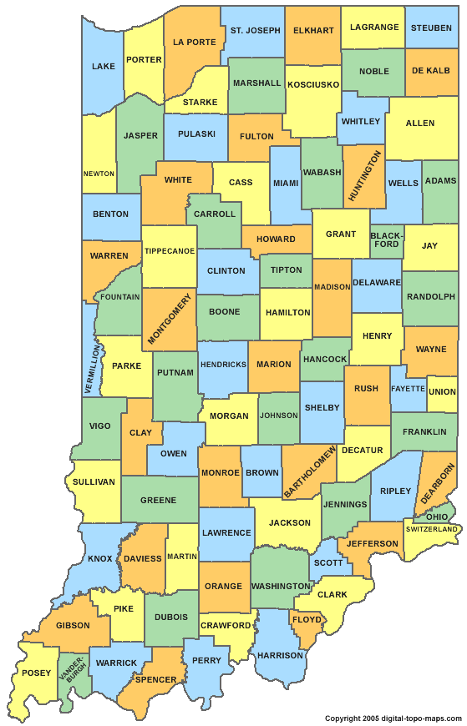
The population of Kosciusko County is described below and is projected to see a slight decrease in the all age groups except the age group of 65+ in the next twenty years.
3 Page

Table 1: Population Projection (2020-2040)
 | Total | Preschool  0-4 | School Age  5-19 | College Age  20-24 | Young Adult  25-44 | Older Adult  45-64 | Seniors  65+
Kosciusko County (2020) | 80,941 | 5,578 | 16,255 | 4,652 | 19,093 | 20,837 | 14,526
 |  | 6.89% | 20.08% | 5.75% | 23.59% | 25.74% | 17.95%
Kosciusko County (2030) | 83,328 | 5,509 | 16,690 | 4,499 | 19,161 | 18,786 | 18,683
 |  | 6.61% | 20.03% | 5.40% | 22.99% | 22.54% | 22.42%
Kosciusko County (2040) | 84,128 | 5,506 | 16,599 | 4,786 | 18,945 | 18,796 | 19,496
 |  | 6.54% | 19.73% | 5.69% | 22.52% | 22.34% | 23.17%
(U.S. Census Bureau, 2018)

Table 2: Child Population
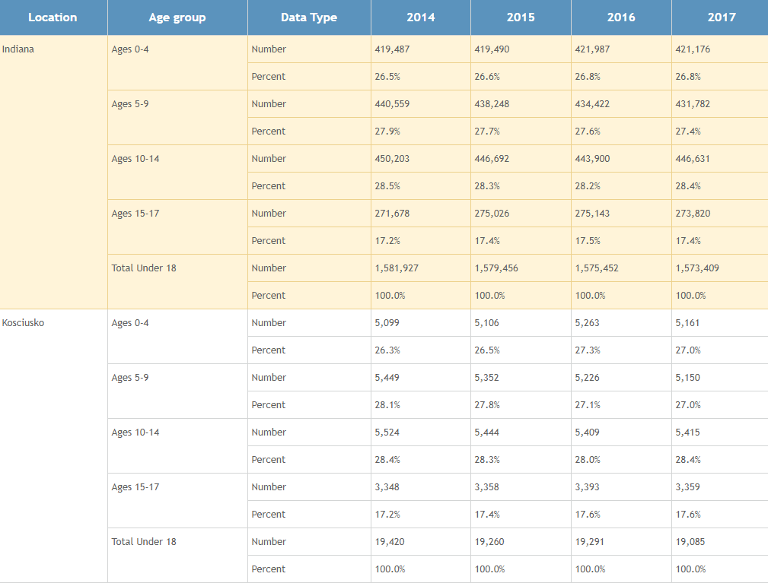
(Kid's Count Data Center, 2014-2017)
4 Page

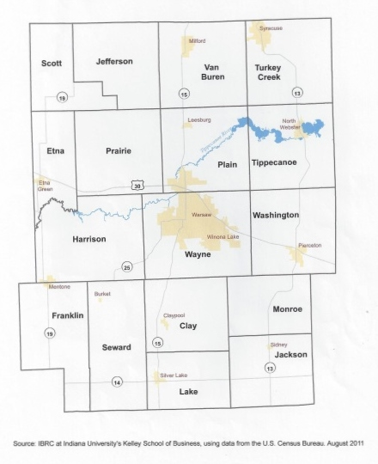
Townships:
There are 17 townships in Kosciusko County.
Image 2, on the right, shows the location of the townships.
Head Start classrooms are located in Wayne, Plain,
Tippecanoe, Cay and Franklin townships.

Image 2: Map of Townships in Kosciusko County, Indiana

Table 3 displays the progress of growth of the different townships from 2010-2019. Wayne Township is the largest growing township and is in the center of the County. In Wayne Township there are 3 Head Start Classroom. Early Head Start travels throughout the county.
5 Page

Table 3: Township Population Growth
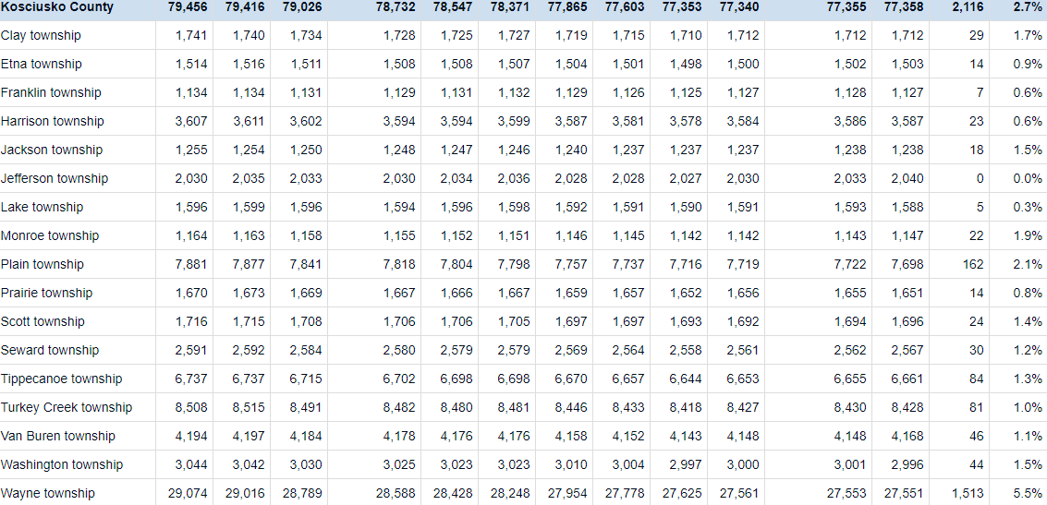
(US Census)

6 Page

Major Cities and Towns:

Image 3: Map of Major Cities and Towns in Kosciusko County
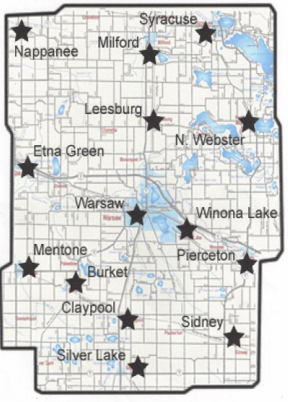

Kosciusko County Head Start classrooms are located in Warsaw, Leesburg, North Webster, Mentone and Claypool.

7 Page

Image 4: Largest Cities and Towns within Kosciusko County

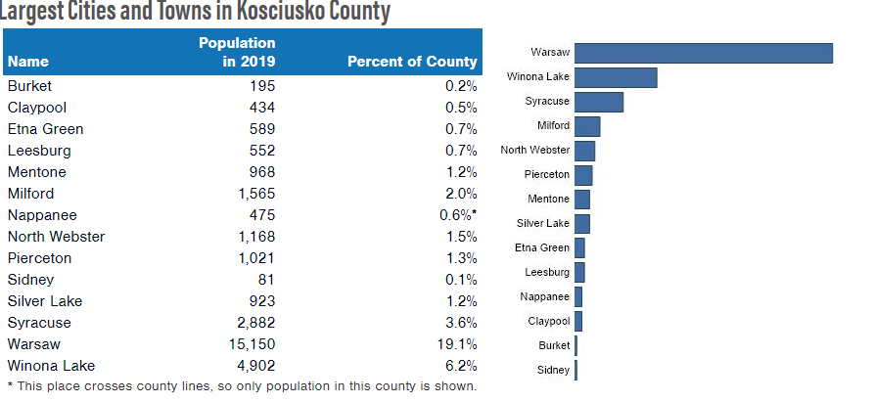
(indianaindicator.org)

Overview of Economic Trends:
Kosciusko County has an overall cost of living index of 81.9 (Best Places, n.d.). This average is under the United States’ level, but it also shows burden of housing and utility costs for the county compared to our neighboring counties. In Kosciusko County, 9 percent of the population is at or below the poverty level (US Census, 2018). There are approximately 8,600 total people in poverty (Data USA, 2017) with 12.3% age zero to seventeen years (Indiana Youth Institute, 2018). With 5,161 children living in the county age 0-4 (Table 2, p. 4) approximately 635 of children are living in poverty and eligible for Head Start/EHS services.

Table 4: Overall Cost of Living Index for Kosciusko Compared with Neighboring Counties
 | Kosciusko Co. | Fulton Co. | Marshall Co. | Elkhart Co. | Indiana | United States
Overall | 81.9 | 73.7 | 78.4 | 79.3 | 82.1 | 100
Grocery | 92.7 | 90.1 | 92 | 91.8 | 92.9 | 100
Health | 82.2 | 77.9 | 80 | 79.1 | 82.2 | 100
Housing | 72.3 | 44.2 | 59.9 | 59.3 | 61.7 | 100
Utilities | 95.2 | 95.7 | 98.1 | 92.7 | 97.2 | 100
Transportation | 68.1 | 74.8 | 72.4 | 77.4 | 85.4 | 100
Miscellaneous | 98.2 | 96.8 | 95.7 | 99.1 | 97.3 | 100

(Best Places, n.d.)

8 Page

Table 5: Median Property Taxes in Kosciusko and Surrounding Counties

Wabash County | $1,113
Fulton County | $1,513
Noble County | $1,725
Kosciusko County | $1,608
Marshall County | $1,815
Whitley County | $2,005
Elkhart County | $2,310
(Smart Asset, 2020)

Income:

Image 5: Working Families below 200% Poverty (2007 to 2016)

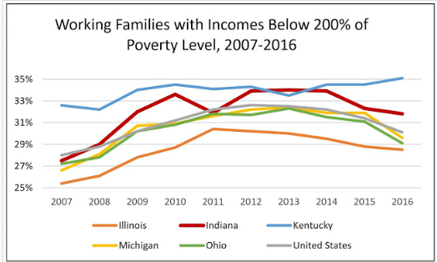
(Bradley, 2018)

Table 6: Median Household Income
Location | 2013 | 2014 | 2015 | 2016 | 2017
Kosciusko Co. | $51,603 | $54,068 | $52,821 | $56,010 | $62,666
Indiana | $47,508 | $49,384 | $49,225 | $52,289 | $54,134
National | ---- | ---- | ---- | ---- | $61,937
(Kid's Count Data Center, 2014-2017) And (U.S. Census Bureau, 2018)

Table 7: Per Capita Income
Location | 2013 | 2014 | 2015 | 2016
Kosciusko Co. | $38, 915 | $40, 469 | $44, 864 | $42, 278
Indiana | $38,291 | $39,578 | $41,940 | $43,097
National | ----- | ---- | ----  9 Page | $32,621
(Kid's Count Data Center, 2014-2017) And (U.S. Census Bureau, 2018)

Unemployment Rates:
As of April 2020, Kosciusko County had an unemployment rate of 19.2 percent. This is the highest unemployment rate the county as experienced compared to previous months and previous years (Bureau of Labor Statistics, 2020). For example, in the previous month the unemployment rate was 2.7 percent. This spike could be due to the Coronavirus, also known as COVID-19, health pandemic which resulted in a statewide shut down causing many individuals to be laid off from work for a long period of time.

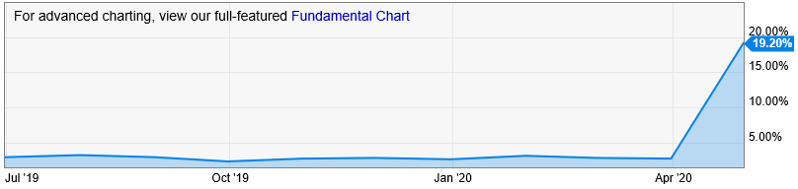
Image 6: Unemployment Rates (July 2019- April 2020) in Kosciusko County
(Bureau of Labor Statistics, 2020)

Race and Ethnicity:
The ethnicity majority of the population of Kosciusko County is white at 95.2%, which is above the state average of 84.8%. The population identifying as Hispanic is 8.2%, which also ranks higher than the state average of 7.3%.

Image 7: Racial and Ethnic Groups within Kosciusko County
How diverse are we in terms of race and ethnicity? 2019 | Number | Rank of | Percent  in County | Percent  in State
American Indian or Alaska Native Alone | 336 | 21 | 0.4% | 0.4%
Asian Alone | 1,387 | 19 | 1.7% | 2.6%
Black Alone | 913 | 32 | 1.1% | 9.9%
Native Hawaiian and Other Pac. Isl. Alone | 46 | 22 | 0.1% | 0.1%
White | 75,660 | 18 | 95.2% | 84.8%
Two or More Race Groups | 1,114 | 25 | 1.4% | 2.2%
Hispanic or Latino Origin (can be of any race)
Non-Hispanic | 72,973 | 22 | 91.8% | 92.7%
Hispanic | 6,483 | 12 | 8.2% | 7.3%

(IndianaIndicators.org)
10 Page

The non-white population in Kosciusko County includes but is not limited to Asian, Hispanic, and Black. The Hispanic group is the minority group within the county. The majority of the Hispanic population reside in the city of Milford.

Image 8: Non-White Population Groups within Kosciusko County
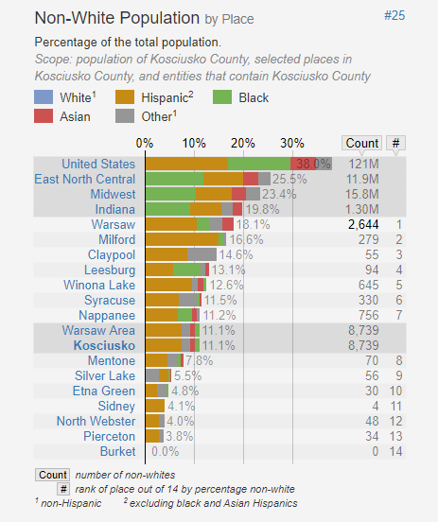
(Statistical Atlas, 2020)
Language
According to the US Census 2018 ACS 5-year survey, 89.67% of Kosciusko County residents speak only English, while 10.33% speak other languages. The non-English language spoken by the largest group is Spanish, which is spoken by 5.80% of the population.
11 Page

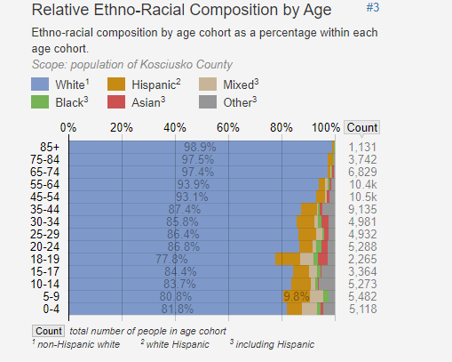
Image 9: Ethno-Racial Population Groups by Age within Kosciusko County

(Statistical Atlas, 2020)

Public Assistance Data:
In 2019, Kosciusko County had 31 families on TANF, 4,454 receiving food stamps, and 5,914 receiving free lunches. But, since the Coronavirus pandemic has impacted the area, those numbers have seen an increase.

Table 8: Number of families receiving public assistance
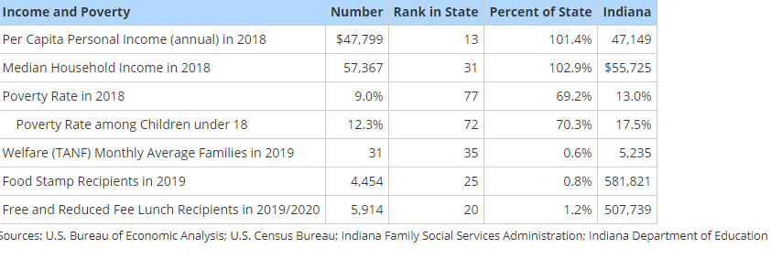
12 Page

(Indiana Department of Education, 2020)

From April 2019 to April 2020, there was a significant change in the number of families who were receiving TANF benefits. There was a 50 percent increase in one parent families receiving TANF, an increase in the number of children grant recipients by 109.76, there was a 33 percent decrease in two parent families receiving TANF, and a decrease in child recipients by 60 percent. This change could be due to the COVID-19 pandemic.

Table 9: Kosciusko County Public Assistance Data shows time during COVID.
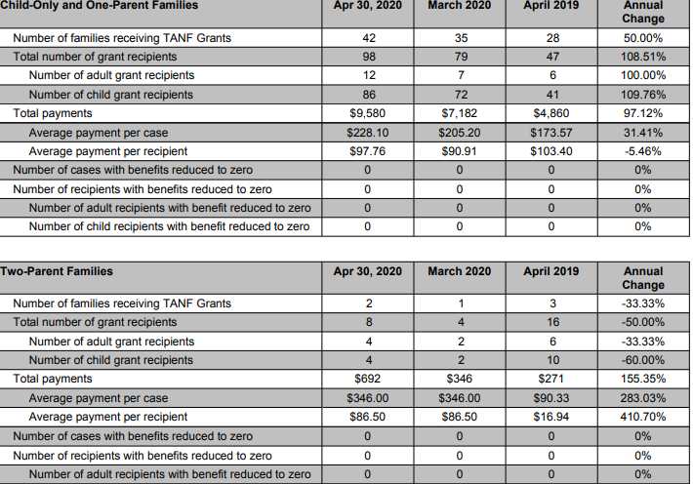

(Sullivan, 2020)

There has been an increase in the number of families who receive SNAP benefits. In April 2019, there were 486.6 households receiving SNAP. However, in April of 2020, that number has increased by 87 percent. The amount of household recepients in April 2020 totaled 909.2.

13 Page

Image 10: Numbers of families receiving SNAP benefits

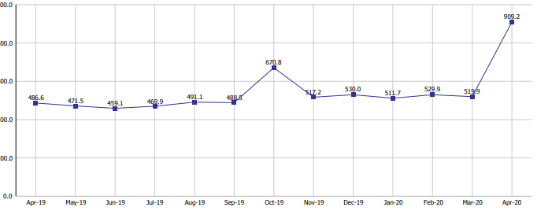

(Sullivan, 2020)

Homelessness:
Fellowship Missions
1520 E. Winona Avenue • Warsaw, IN 46580 • 574-268-9555
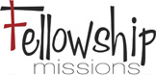 is a not for profit Christian based relief ministry serving the communities of Warsaw, Winona Lake and surrounding areas. The organization was founded by Eric and Tammy Lane in April of 2010. Lane states, “The purpose is to meet the needs of the hurting and broken people in the Kosciusko County community through sharing the love and hope of Jesus Christ.”
Fellowship Missions is at 100 percent capacity every night. They have 46 beds for men, women and children: 22 beds for women and 24 beds for men. 95 percent of the residents are from Kosciusko County, which is an increase from five years ago at 75 percent. According to Lane, on any given night in Kosciusko County, there are 200-300 homeless men, women and children. Fellowship Mission served 70 homeless children this past year. (Lane, 2020)

This year Fellowship mission has expanded its services to include addiction recovery. Fellowship Mission Recovery Services offers supports to addicts by connecting them to community resources as well as providing small group supports.

During the COVID- 19 quarantine, the shelter moved its residents to a local camp and was able to use its lodges to safely quarantine everyone. Nine of the residents were considered essential workers and stayed in the shelter on Winona Ave. Warsaw (Lane, 2020).
14 Page

Poverty Rate and Food Insecurity:
The poverty rate is an economic indicator that measures the percentage of people with income below the poverty threshold. According to the (US Census, 2018), Kosciusko County has a poverty rate of 9 percent. This percentage was found to be lower than the state’s average poverty rate, which was 13.1 percent, for the same time period. Even the US National average is higher at 11.8 percent in 2018 (US Census, 2018).

Table 10: Food Insecurity Rates
 | Population | Food Insecurity Rate | Food Insecure Individuals | % below 130% poverty | % between 130% and 185% poverty | % above 185% poverty
Kosciusko | 79,344 | 10.9% | 8,600 | 46% | 25% | 28%
Indiana | 6,732,219 | 13.2% | 883,260 | 52% | 16% | 32%
USA | 328,239,523 | 11.25% | 37,227,000 | 49% | 19% | 32%
(Feeding America, 2018)

Transportation:
According to the (US Census) as of 2018, there were 1,638 individuals within Kosciusko County who did not have transportation available. With this in mind, these individuals have to search for other means of transportation such as public transportation, walking, and carpooling. In fact, it was noted by the (US Census, 2018) in the following chart that roughly 4,725 county residents would carpool, 517 people would walk, 605 people would bike, and 48 people utilized public transportation. There is an average commute time of 19.5 minutes for Kosciusko County residents. (U.S. Census Bureau, 2018). “KABS” (Kosciusko Area Bus Service) is one of the public transportation options in the county. KABS provided 57, 165 rides in 2018 and 59,652 rides in 2019 (Cardinal Services of Indiana, INC, 2017) (Peterson, 2020).

Table 11: Available transportation to residents within Kosciusko County
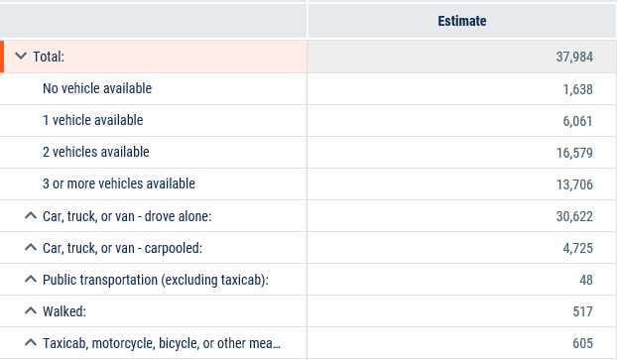

15 Page

(US Census, 2018); (Cardinal Services of Indiana, INC, 2017); (Peterson, 2020)

Housing:
73.6 percent of Kosciusko County’s housing units are occupied and 18.1 percent are rentals. On average, 30 percent of household income is used for rent. The median age of homes in Kosciusko County is 32 years. The county has 0.4 percent of homes lacking complete plumbing and 4.9 percent of homes have no telephone (U.S. Census Bureau, 2018) and (Best Places, n.d.) and (Infoplease, 2017).

(STATSIndiana, 2018)
In Kosciusko County there are approximately 72 Mobile Home Parks.

Table 13: Kosciusko County Mobile Home Parks
Home Park | City | Mobile Home Park | City | Mobile Home Park | City | Mobile Home Park | City
Browns Landing | Claypool | Elmwood Estates | Syracuse | Russ Fahls Park | Warsaw | Pine Bay MH Park | Leesburg
Burket MH Park | Mentone | Merrywood MH Park | Warsaw | Genes MH Park | Warsaw | Blacks Court | N. Webster
Caldwell Lake | Claypool | Musquabuck Meadows | Syracuse | Shamrock Village | Warsaw | Secrest Manor MH Park | Leesburg
Claypool MH Park | Claypool | Pinecrest MH Park | Syracuse | Suburban Acres Mh Park | Warsaw | Northside MH Park | Mentone
Compass Court | Claypool | Turtle Bay Estates | Syracuse | Village Mh Park | Warsaw | Stumps | Pierceton
Country Meadows | Syracuse | Northcrest MH Park | Warsaw | Graceland Village | Warsaw | Bowmans Landing | Silver Lake
Cripple Gate Mh Park | Leesburg | Green Acres MH Court | Warsaw |  |  | Midlakes MH Park | N. Webster
Crowls Landing | Syracuse | Patona Bay | Warsaw | Longs MH Park | Leesburg | Millers MH Park | Mentone
Diamond Lake MH Park | Claypool | Waveland Beach MH Park | Syracuse | Warsaw MH Park | Warsaw | Stevens Mh Park | Pierceton
Etna Green MH Park | Etna Green | Dwyers MH Park | Warsaw | Whispering Pines Park | Warsaw | Harris MH Park | Silver Lake
Grays Riverview Mh Park | Leesburg | Hideaway Mh Park | Warsaw | Fairlane | Winona Lake | Ponderosa MH Park | N. Webster
Hill Lake Resort | Claypool | Wawasee MH Park | Syracuse | Westhaven Estates | Warsaw | Joyland MH Park | N. Webster
Kalorama Park | Leesburg | Lakes Estates MH village | Warsaw | Tenabe Mh Park | N. Webster | Lakeshore MH Park | Winona Lake
Lakeview MH Park | Leesburg | Lozier MH Park | Warsaw | Felaboms | Warsaw | Milford MH Park | Milford
Mikel Mobile Estates | Etna Green | Hideaway Hills | Warsaw | Windstar MH Park | Warsaw | Lakes Estates MH Village | Warsaw
Muskelunge Lake MH Park | Claypool | Bar B Landing | Warsaw | Home Place MH Park | Warsaw | Marsh Landing | N. Webster
Shady Acres | Claypool | Browns MH Park | Warsaw | Merrywood MH Park | Pierceton | Bowmans Landing | Silver Lake
Tillmans MH Park | Claypool | Clearwater Mh Park | Warsaw | Pleasant Acres MH Pk | Pierceton | Walsh MH Park | Silver Lake
Tippe MH Court | Leesburg | Marsileete MH Park | Warsaw | Forest Park | Warsaw | Waubee Lake MH Park | Milford
16 Page

Other Child Care Programs in Kosciusko County
The charts below outline the other childcare and preschool programs in Kosciusko County. Childcare and preschool providers who accept CCDF (Child Care Development Fund) dollars are marked with an asterisk (*). Childcare and preschool providers who accept CCDF (Child Care Development Fund) dollars and On My Way PreK dollars are marked with a double asterisk (**). Child Care and Preschool programs in the state have the option to participate in Paths to Quality, and On My Way PreK programs. Most must be state licensed through the Office of Early childhood and Out of School Learning (OECOSL).
Paths to Quality gives families an easy to recognize tool for selecting a program. Families can look for the Paths to Quality logo to determine what level their provider has achieved. Each level builds on the foundation of the previous one, resulting in significant quality improvements at each stage and in national accreditation at the highest level. The system validates providers for ongoing efforts to achieve higher standards of quality and provides incentives and awards for success. The four levels address:
- Level One: Health and Safety needs of children met.
- Level Two: Environment supports children’s learning.
- Level Three: Planned curriculum guides child development and school readiness.
- Level Four: National accreditation (highest indicator of quality) is achieved.
The vision of the Office of Early Childhood and Out of School Learning (OECOSL) is that every Indiana community will have a strong network of Early Care and Education (ECE) and Out-of- School time (OST) programs that support the child, the family and local schools. Programs will be high quality, affordable and accessible, enabling families to work effectively to obtain economic self-sufficiency. Children will thrive in programs that meet their developmental and educational needs and make them feel welcome, encouraged and supported. Professionals teaching and caring for children will have the resources, including training and education, needed to operate and maintain high quality programs.
On My Way Pre-K awards grants to 4 year olds from low-income families so they may have access to a high-quality pre-K program the year before they begin kindergarten. Families who receive a grant may use the grant at any approved On My Way Pre-K program. Programs must have a level 3 or 4 Paths to Quality rating to be an On My Way PreK provider.
Provider Type: Licensed Centers
17 Page

Center | Paths to Quality Rating
Growing Kids Learning Centers **  Warsaw | 3
Kosciusko County Head Start **  Claypool | 3
Kosciusko County Head Start **  Leesburg | 3
Kosciusko County Head Start **  Mentone | 4
Kosciusko County Head Start **  North Webster | 4
Kosciusko County Head Start**  Warsaw | 4
New Beginnings Preschool &Childcare Milford ** | 4
Growing Kids | 3
KinderCare **  Warsaw | 3
KinderCare II *  Warsaw | 1

Provider Type: Licensed Homes
Home | Paths to Quality Rating
Gail Olds- Warsaw | 1
Debbie’s Daycare- Warsaw | 0
Silveus Daycare- Pierceton * | 1
Little Angels-Warsaw* | 1
Elrod Daycare- Warsaw * | 0
Erica Thacker-  Creative Cubs Childcare-Warsaw * | 0
Chrisy Licensed Daycare- Pierceton * | 1
Donna’s Bus Stop- Pierceton * | 0
Carol’s Daycare- Warsaw * | 0
Teen Parents Succeeding- Syracuse * | 2
Christine Stump- Warsaw | 2
Leticia Howell- Syracuse * | 1

Provider Type: Unlicensed Registered Ministries
18 Page

Ministry | Paths to Quality Rating
Little Steps  Warsaw | 0
Lighthouse Childcare  Warsaw | 0
Kiddie Kare Childcare Ministry  Winona Lake | 0
Bright Beginnings Daycare & Preschool  Warsaw | 0
Little Lambs Preschool Daycare Ministry, Syracuse | 0
Preschools
School: | Location:
Warsaw Christian Schools | Warsaw
Presby Preschool | Warsaw
Sacred Heart | Warsaw
The Ark Christian Preschool | North Webster
Jack and Jill Preschool | Mentone
Greater Warsaw Cooperative Preschool | Warsaw
Good Shepherd Preschool | Winona Lake
Kiddie Kollege | Winona Lake
Mentone Kindergarten Readiness Center | Mentone
Sonshine Preschool | North Webster

Services for Young Children with Disabilities
First Steps is the Zero to Three Part C provider of the IDEA for the state of Indiana. In Kosciusko County from 04/01/2019 to 3/31/2020, First Steps supported 215 children. Of the 215 children, 13 were zero to one year old, 45 children were one to two, and 157 were two to three years old. (Fairchild-Leazenby, 2020). The services that are provided by First Steps meet the children’s needs in developmental delays, physical disabilities, and speech delays. To qualify for services, the children must show 20 percent delay in two areas, 25 percent delay in one area, or have a diagnosis of a physical or mental condition that has a high probability of resulting in developmental delay (IN.gov, 2020) . The Part B provider (ages three to 21) of the IDEA is the Local Education Agency (LEA) which is a part of the local school systems. The LEA of the Warsaw Community School system reported serving 113 preschoolers (Northern, 2020), the LEA of Wawasee School system reports supporting 50 children (Scheidt, 2020), and as of April 1, 2020, Tippecanoe Valley School reported serving 26 children aged three to five (Wilks, 2020).
Below is a list of agencies in the community that serve children with disabilities:
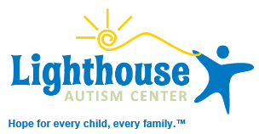

Lighthouse Autism Center
1535 Provident Drive • Warsaw, IN 46580 • 574-387-4313
Provides center-based Applied Behavioral Analysis (ABA) therapy. Lighthouse Autism Center has an array of locations within the Indiana and Michigan area; therefore, families are able to find an office that is closest to them so they can access the care needed for their child or children (Lighthouse Autism Center, 2016). Lighthouse Autism Center has limited spots for the 40 hour per week program, which is provided year-round. Currently in the Warsaw location there are 17 children receiving these services and of these 17 children, there are six who are five years of age or younger (Taubert, 2020)
19 Page

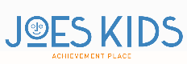

Joe’s Kids
3540 Commerce Drive • Warsaw, IN 46580 • 574-376-2316
Joe’s Kids provides physical, occupational, and speech therapy services for children with many different conditions and disabilities ranging from short term to long term conditions. All children need to have a medical diagnosis in order to qualify for services. A few examples would be sensory processing disorder, Cerebral Palsy, Down syndrome, Autism, speech delay, and more. However, it was stated that “some of the children referred to Joe’s Kids do NOT have a formal diagnosis and are referred simply for “developmental delay” (Bazzoni, 2020). They receive referrals from many avenues including parents who are seeking therapy for their children and physician offices. Joe’s Kids also provides free developmental screenings to those interested, and parents or teachers can refer to Joes’ Kids for a screening. If a child completes this screening and it is found they need a formal evaluation and treatment, Joe’s Kids can help pursue the referral from the child’s primary physician (Bazzoni, 2020). All children must have a physician prescription in order to receive services. In the 2018- 2019 school year, Joe’s Kids served just over 400 children, and of these, approximately 60% of the caseload was under the age of 6 (Bazzoni, 2020).

Education, Health, Nutrition, and Social Services

Education: Kosciusko County Schools:
The map below shows the education options for students living in Kosciusko County. The Wa-Nee and Triton School Corporations serve Kosciusko County students, but they do not have school buildings within the county. Kosciusko County Head Start and Early Head Start collaborates with these school corporations when there is a need present. There are also options for alternative education through Tippecanoe Valley’s Burket Educational program and Warsaw’s Gateway Alternative Education program.
20 Page

Image 11: Map of School Districts in Kosciusko County
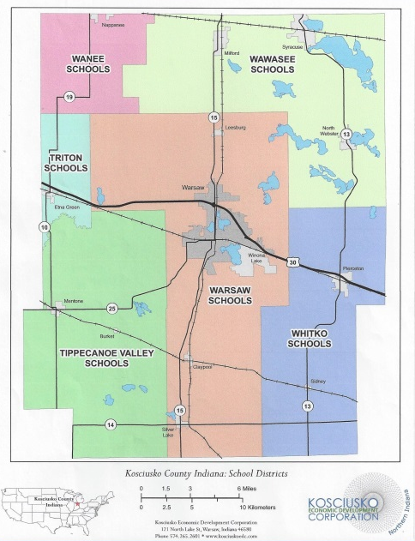

Kosciusko County offers public and private schools as well as post- secondary education. See chart below.

21 Page

Table 14: Available Educational Options
Public Schools Systems | Private Schools | Post-Secondary Schools in Kosciusko County
Tippecanoe Valley Schools | Lakeland Christian Academy | Grace College
Warsaw Community Schools | Monarch Christian Academy | Indiana Tech
Wawasee Community Schools | Sacred Heart Catholic School | Ivy Tech Community College
Whitko Community Schools  (School Map, 2020) | Warsaw Christian School | Trine University (Grace College)

Post-Secondary Schools within an hour | Indiana’s Major Universities
Ancilla College | Anderson University
Bethel College | Ball State University
Freedom Academy | Butler University
Goshen College | Indiana University (7 regional sites)
Holy Cross College | Purdue University (5 regional sites)
Huntington University | Trine University
Indiana University/Purdue University-Ft. Wayne | University of Notre Dame
Indiana University-South Bend | University of Saint Francis
Indiana Tech | Valparaiso University
Indiana Wesleyan University | Vincennes University
Manchester University | University of Evansville
University of Notre Dame
University of St. Francis

As the data above describes, there are several schools available for degree completion and furthering one’s education. However, Table 15 below shows that Kosciusko has 5.7 percent of individuals over the age of 25, who reside in Kosciusko County have less than ninth grade education. Also, it was noted that 8.8 percent of the population, do not have a high school diploma or GED.

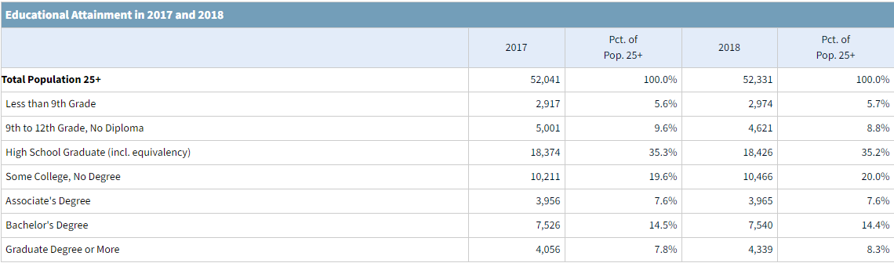
Table 15: 2018 Educational Attainment (Total Pop. 25+)

(STATSIndiana, 2018) *The percentages listed in the table above are Kosciusko County’s data.
22 Page

Health and Nutrition:

General Health Issues
In Indiana, there were 1,439,013 people covered by Medicaid/ CHIP insurance services as of July 2018 (Norris, 2018). Eligible people lose their Medicaid when the requirements of the program or the redetermination process are not followed. For example, in 2019 the state implemented a work requirement called “Gateway to Work”; this recent requirement requested that the Medicaid insurance holder must have a stable job (Ku, 2019). However, a person could experience job loss at any point in time; therefore, a service provider such as Brightpoint can aid in finding medical coverage for people in need.

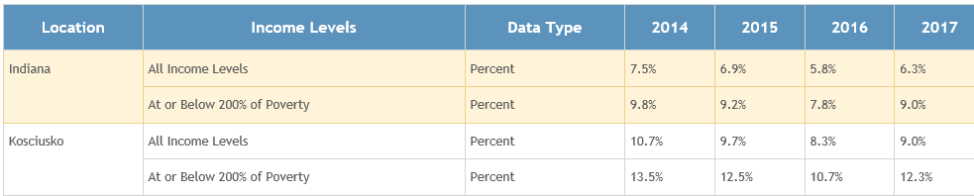
Table 16: Uninsured Children under Age 19
(Kid's Count Data Center, 2014-2017)
Brightpoint is an organization which provides many services to the people of Northern Indiana. One of these services is to assist people with obtaining Hoosier Healthwise Insurance. Brightpoint is also the State’s Child Care Development Fund (CCDF) administrator for Region 2A. This program issues subsidized child care vouchers to eligible families to help them return to work. In 2017, 141 Kosciusko County children were enrolled in the program (Kid's Count Data Center, 2014-2017).
The people living in Kosciusko County also deal with major health concerns and risk factors. In 2016, 14.3 percent of the county’s women smoked while pregnant and in 2017 the number increased to 15.1 percent (IN.gov, 2020) and (Kids Count , 2017). According to the ALA (American Lung Association, 2020), 1,646 children deal with pediatric asthma, 5,993 adults have been diagnosed with adult asthma, and 5,656 people have been diagnosed with COPD. Although smoking is a health risk, the county has also experienced an increase in the number of persons using e-cigarettes, also known as vaping. According to (Stephenson, 2019), it was mentioned that the Centers for Disease Control and Prevention found Indiana has the third highest vaping rate in the country. However, it is not just adults who use; roughly 3.6 million middle school and high school students also use the e-cigarettes/vaping pens. Some of the reasons that youth are experimenting with vaping is for the following reasons; curiosity, taste, and the belief that the vaping is “safer” than smoking cigarettes. As a result of this high rate, the county has a specific advocacy group called the Kosciusko County Tobacco Free Coalition. The purpose of the Kosciusko County Tobacco Free coalition is to “improve the health of Hoosiers in Kosciusko County and reduce the disease and economic burden that tobacco use can place on Kosciusko County residents of all ages” (Blake, 2020). Other health risks that residents of the Kosciusko County are experiencing as followed; diabetes, currently 8.8 percent of adults are diagnosed, and obesity, 29 percent of adults are listed as obese. The number of those individuals with diabetes was found to be lower than the state’s average. However, the number of obese people is higher than the state of Indiana’s average (National Initiative for Children's Healthcare Quality, 2020). According to Kids Count data, the child food insecurity rate in Kosciusko County is 16.1% compared to 17.7% in the state of Indiana.
23 Page

The Kosciusko County Health Department currently houses the Early Prenatal Clinic and the Immunizations Clinic. The Prenatal Care Clinic offers services for pregnant women, education on prenatal and newborn care, assistance with Medicaid applications and prenatal vitamins (Kosciusko County: Health Department, 2020). The Immunization Clinic offers free immunizations to children who are on Medicaid or uninsured; however, it was mentioned on their site, “beginning January 1, 2020, there will be a $15 fee per shot (Kosciusko County: Health Department, 2020). The Immunization Clinic also offers lead screenings, by appointment only, to children in need of a screen.
The table below shows state and county percentages of children with completed immunizations.

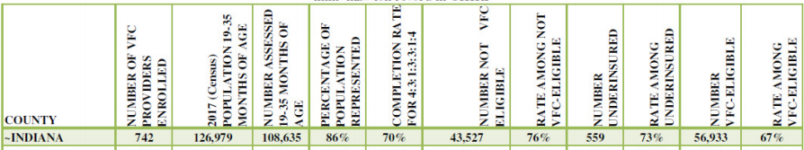
Table 17: Percentage of children who current on immunizations
(King, 2020) and (Cameron, 2019)

Northern Indiana Hispanic Coalition:
This coalition exists to overcome barriers in knowledge, transportation, and language to open healthcare access in addition to addressing the Hispanic community’s unique health concerns regarding •Cardiovascular disease/stroke – leading cause of death
•Female obesity – highest rate of any ethnic group
•Diabetes – twice as likely to develop diabetes compared to non-Hispanics
•Cervical cancer – 2.5 times higher rate than Caucasians

Maternal and Infant Health Care and Nutrition:
Table 17 shows a decrease in the number of infants born with low birth weight from 2014 to 2017, while Table 18 shows the county having a lower rate of mothers receiving first trimester prenatal care. CDC data also indicates The Infant Mortality Rate (IMR) for Indiana is 7.3 and the county IMR is a higher at 7.5. Table 19 shows the teen birthrate in Kosciusko County. Based on the number of births in the county with 12.3% poverty rate, approximately 131 pregnant women are eligible for EHS services each year.
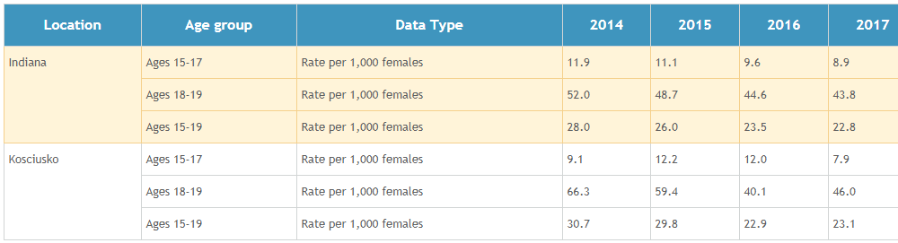
Table 18: Teen Birth Rate per 1,000 Females by Age
24 Page

(Kids Count Data Center, 2017)

Table 19: Infant Data
Location | Topic | Data Type | 2014 | 2015 | 2016 | 2017
Kosciusko County | Live Births | Number | 1, 080 | 1, 027 | 1, 017 | 1, 057
 | Low Birth weight | Percent | 7.6% | 6.0% | 7.5% | 6.7%
 | Infant Deaths | Number | 9 | 7 | 7 | 9
Indiana | Live Births | Number | 83, 927 | 84, 008 | 83, 063 | 82, 251
 | Low Birth weight | Percent | 8% | 8% | 8.2% | 8.3%
 | Infant Deaths | Number | 597 | 613 | 623 | 602

(Kids Count Data Center, 2017)

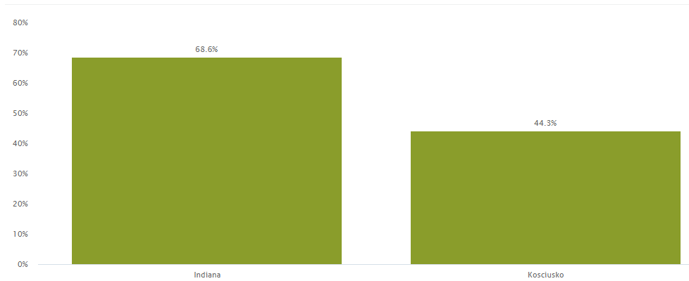
Image 12: Mothers Who Receive First Trimester Prenatal Care
25 Page

(Kids Count Data Center, 2017)
Below are some agencies in the county that provide services to pregnant women:

Heartline Pregnancy Center
1515 Provident Drive, Suite 180 • Warsaw, IN 46580 • 574-267-5110
• Pregnancy Testing/Verifications
• Limited Obstetrical Ultrasound
• Adoption Information
• Abortion Information
• Ongoing Pregnancy and Parenting Support
• Community Resource Information
• Car Seat Inspections and Fittings
• Baby Supplies through the BABE Boutique
• Childcare & Preschool Information
• Post-Abortion Support
• Sexually Transmitted Infection Testing and Education
• Sexual Integrity Education

Women, Infants, and Children (WIC) Program
1515 Provident Drive, Suite 180 • Warsaw, IN 46580 • 574-269-4456
WIC is a nutrition program that helps pregnant women, new mothers, infants, and children eat well and stay healthy. WIC provides the following assistance to families by offering healthy foods designed to meet special nutrition needs, nutrition and health screening and assessment, nutrition education and counseling, and breastfeeding support, including breastfeeding moms receiving more nutritious foods from WIC and mom-to-mom support from Peer Counselors. From the chart below, one can see that there was an increase in the program during the years of 2016 to 2017. According to the Kosciusko County WIC Coordinator, there has been a ten percent increase in participants during the COVID -19 pandemic. In December 2019 there were 1,530 participants and in June 2020 there were 1,780 participants. WIC currently serves 113 pregnant women, 119 breastfeeding mothers, 114 non-breastfeeding mother, 1,069 children, and 314 infants. (Kneller, 2020).

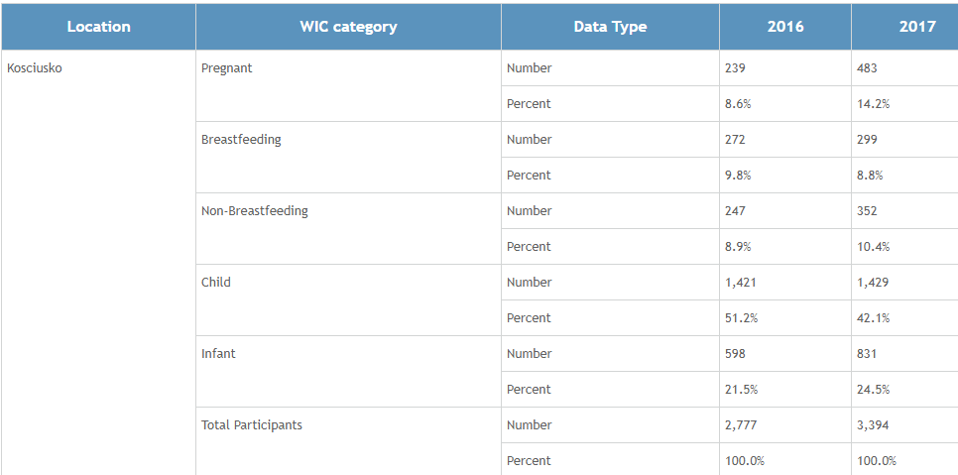
Table 20: Number of Individuals on WIC
26 Page

(Kids Count Data Center, 2016- 2017)

Mental Health:
According to (National Alliance on Mental Illness, 2020), one in five US citizens experience mental illness and 17% of children, aged six to seventeen, experience a mental health disorder. Kosciusko County has mental health providers so that the community can seek the appropriate care needed in order to learn, grow, and overcome mental health issues. Some of the facilities available are, the Bowen Center, which is the largest mental health provider in Kosciusko County and they accept Medicaid. Other mental health providers in the county are Hambright & Associates, Raising Hope Counseling, McArthur Counseling Center, Brown and Associates, Biblical Counseling INC., First United Methodist Counseling, Lifetouch Ministries, and Turning Point Counseling Center. The residents of Kosciusko County have multiple options in order to properly receive mental health assistance.

Dental Health:
In Kosciusko County there is a lack of eligible dental providers for those on Medicaid. Due to this issue, long wait times for appointments force families to travel out of county to receive needed treatment needed.
According to (Burns & Associates, 2018), they found that in Indiana, “primary care visits were more prevalent among the youngest members, as 93 percent of children ages 5 and younger had a visit in FFYs 2015 and 2016. The percentage was lower for children in the other age groups (81% for age 6-12 and 77 % for age 13-18).” The table below displays the number of children on Medicaid in Indiana who had received dental services during the years 2016 to 2018.

Table 21: Dental Health among Preschool and School Aged Children
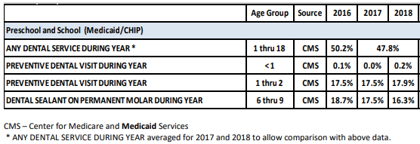
(Indiana State Department of Health , 2020)
Social Services:

Child Abuse and Neglect:
According to the Kids Count datacenter, in 2017 the Child Abuse and Neglect Rate (per 1,000 children under the age of 18) was 20.8 for Indiana and 12.3 for Kosciusko County. Refer to Table 20. For that same year, 36 children were declared as Children in Need of Services (CHINS) in Kosciusko County. However, as current as June 2020, the (Department of Child Services, 2020) has found that the state of Indiana has substantiated, meaning there was evidence proving, 187 cases of child sexual abuse, 115 cases of child physical abuse, and 1,472 cases of child neglect. Kosciusko County was found to have 4 cases of child sexual abuse, 0 cases of child physical abuse, and 10 cases of child neglect. These numbers are much lower than June 2019 results; this could be due to the lack of reporting since the county had experience a mass shut down of schools, churches, and other community areas due to the COVID-19 pandemic.
27 Page

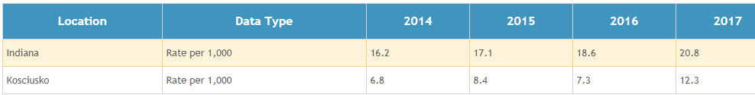
Table 22: Substantiated Abuse and Neglect Cases
(Kid's Count Data Center, 2014-2017)

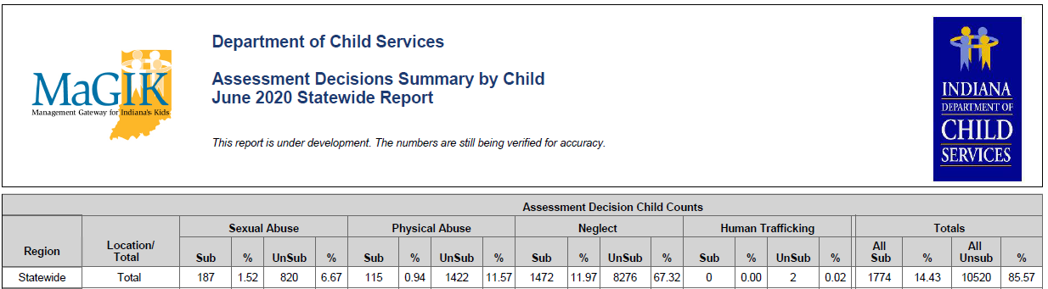
Table 23: Department of Child Services- Substantiated Abuse and Neglect Cases as of June 2020
(Department of Child Services, 2020)

Foster Care:
The table below shows the number of children involved with the Department of Child Services of Kosciusko County during the last five years. The number of CHINS (children in need of services) increased in 2018 and 2019, and in 2020 the percent of CHINS being placed out of the home is the highest it has been in the last five years (Castro, 2020).

28 Page

Table 24: Department of Child Services- Number of Children in Foster Care
Year | CHINS | Children placed out of the home | Relative care | Foster care
June 2020 | 87 | 83/95% | 42/50% | 41/49%
June 2019 | 126 | 93/74% | 51/ 54% | 41/49%
June 2018 | 134 | 98/74% | 68/69% | 30/30%
June 2017 | 83 | 63/76% | 42/66% | 19/30%
June 2016 | 57 | 44/77% | 24/57% | 18/40%
June 2015 | 69 | 55/78% | 37/67% | 16/ 29%

Indiana 2019 Kids count Data Book Snapshot indicates that CHINS, child abuse and neglect as well as children in Foster care has increased from 2018 to 2019.

Image 13: Indiana KIDS COUNT Snapshot
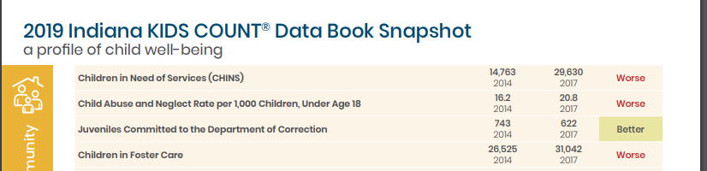
(Indiana Youth Institute, 2019)

Domestic Violence: The Beaman Home
In 2019, the Emergency Shelter provided service to 333 individuals; 104 of those were children. Participants stayed for a total of 5,928 nights and averaged 24 nights (Hayes, 2020). The shelter provides nutritious meals and snacks, clothing and personal care items, case management with goal setting, job search assistance, and social services and counseling referrals.
The Beaman Home’s Community Education Services teaches the community about healthy relationships for teens, abuse awareness training, and incarcerated women’s support group.
The Basic Care Center provides much needed clothing, linens, household items, furniture, and more to over 30 families of the Beaman home who are struggling to make ends meet. All services are provided free of charge.
29 Page

Meth Lab Seizures
In 2020, there were 43 meth labs seized in Kosciusko County ranking the county with the second largest number of meth seizures in the state. The third ranked county borders Kosciusko County to the northeast. Noble County had 57 meth labs seized in 2020. In Indiana, there were a total of 2, 867 seizures of meth labs in 2020 (IN.gov, 2020).

Kosciusko County Jail Bookings
The county jail is located in the county seat, Warsaw. As of 2019 the top jail books were as followed; failure to appear, possession of a controlled substance; for example, marijuana or meth; operating a motor vehicle while under the influence of drugs or alcohol, theft, probation violation; domestic battery (Coney, 2020). Below, in table 24 displays the crime activity level in Kosciusko County compared to the Warsaw metropolitan area and the state of Indiana. The county is comparable in numbers to that of the city and state. Table 25, see below, is comparing the numbers of jail bookings within Kosciusko County jail for the past three years. This table also breaks down male and female bookings, and it is showing daily bookings.

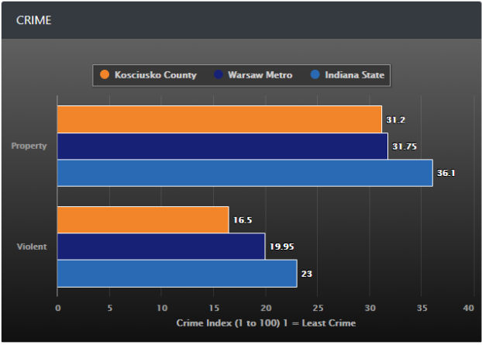
Table 25: Crime Comparison of Kosciusko County to Warsaw Metro and State of Indiana
30 Page

(Best Places, n.d.)

Table 26: Kosciusko County Jail Bookings
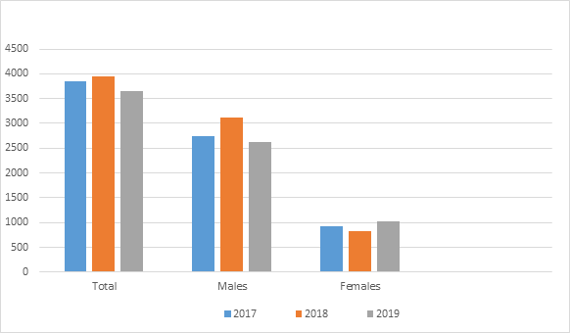
(Coney, 2020)

Head Start and Early Head Start Children and Families

Introduction and Demographics
Kosciusko County Head Start and Early Head Start are comprised of a diverse group of parents and families. Below are charts that include specific details about the families enrolled in the programs in the last three years.

31 Page

Table 27: Demographics: Race and Ethnicity
HEAD START DATA
Year | TOTAL | Ethnicity |  | Race
 |  | Hispanic/Latino | Non-His/No Latino | Asian | Indian  Alaskan | Black | White | Multi/Bi racial | Native Hawaiian | Other
2017-2018 | 160 | 42 | 118 | 3 | 1 | 6 | 100 | 19 | 0 | 31
2018-2019 | 156 | 37 | 119 | 2 | 1 | 4 | 108 | 14 | 0 | 27
2019-2020 | 161 | 45 | 116 | 1 | 0 | 5 | 101 | 22 | 0 | 32
EARLY HEAD START DATA
YEAR | TOTAL | Ethnicity |  | Race
 |  | Hispanic/Latino | Non -His./Latino | Asian | Indian  Alaskan | Black | White | Multi/Bi Racial | Native Hawaiian | Other
2017-2018 | 72 | 28 | 44 | 0 | 0 | 1 | 39 | 9 | 0 | 23
2018-2019 | 65 | 26 | 39 | 0 | 0 | 1 | 34 | 8 | 0 | 22
2019-2020 | 62 | 27 | 35 | 0 | 0 | 2 | 30 | 7 | 0 | 23

Table 28: Parent Education Level
HEAD START DATA
YEAR | Advanced Education Degree | Some College | High School/GED Graduate | < High School Degree
2017-2018 | 9 | 20 | 87 | 31
2018-2019 | 14 | 11 | 93 | 22
2019-2020 | 13 | 11 | 91 | 33
EARLY HEAD START DATA
YEAR | Advanced Education Degree | Some College | High School/GED Graduate | < High School Degree
2017-2018 | 3 | 1 | 28 | 20
2018-2019 | 3 | 2 | 28 | 18
2019-2020 | 5 | 4 | 26 | 16

Of the enrolled households, an average of 23% of two parent households have two working parents, 70% have one working, and 7% have no parents working. Of one parent households, 50% are working and 50% are not.
Survey results have shown most families have schedules which work with program hours/days. 94% of families are able to utilize the program with current services, and 23% of potential parents are interested in before/after school care.
32 Page

Table 29: Children with Disabilities
HEAD START DATA
YEAR | Open IEP | Total IEP | Non-categorical/ developmental | Speech | Autism
2017-2018 | 17 | 17 | 13 | 4 | 0
2018-2019 | 18 | 18 | 11 | 6 | 1
2019-2020 | 12 | 12 | 7 | 5 | 0
EARLY HEAD START DATA
YEAR | Open IFSP or IEP | Total IFSP or IEP | Non-categorical/ developmental | Speech | Orthopedic
2017-2018 | 14 | 14 | 5 | 8 | 1
2018-2019 | 14 | 14 | 2 | 11 | 1
2019-2020 | 9 | 9 | 1 | 8 | 0

Health and Nutrition

Table 30: Immunizations and Dental Health
33 Page

HEAD START DATA
Year | Total Children | Immunizations |  |  |  |  | Dental Home |  | Dental Services |  |  |  | EHS Preventative Services
 |  | At Enrollment |  | At End of Enrollment |  |  | At Enrollment | At End of Enrollment
 |  | Complete All for Age | Up to Date all Possible | Complete All for Age |  | Up to Date all Possible | Continuous Dental Care | Continuous Dental Care | Received Preventative  Dental Care | Dental Exam Since Last PIR | Needs Dental Treatment | Receiving Dental Treatment | Dental Screen
2017-  2018 | 160 | 143 | 0 | 158 |  | 0 | 110 | 155 | 44 | 46 | 8 | 8 | 0
2018-2019 | 156 | 122 | 0 |  | 151 | 0 | 115 | 150 | 123 | 154 | 20 | 18 | 0
2019-2020 | 161 | 131 | 0 |  | 153 | 3 | 133 | 18 | 86 | 161 | 14 | 9 | 0
EARLY HEAD START DATA
Year | Total Children | Immunizations |  |  |  |  | Dental Home |  | Dental Services |  |  |  | EHS Preventative Services
 |  | At Enrollment |  | At End of Enrollment |  |  | At Enrollment | At End of Enrollment
 |  | Complete All for Age | Up to Date all Possible | Complete All for Age |  | Up to Date all Possible | Continuous Dental Care | Continuous Dental Care | Received Preventative  Dental Care | Dental Exam Since Last PIR | Needs Dental Treatment | Receiving Dental Treatment | Dental Screen
2017-  2018 | 66 | 45 | 0 | 43 |  | 7 | 51 | 55 | 0 | 0 | 0 | 0 | 44
2018-2019 | 59 | 45 | 4 |  | 45 | 4 | 46 | 51 | 0 | 0 | 0 | 0 | 59
2019-2020 | 57 | 42 | 3 |  | 42 | 3 | 26 | 26 | 0 | 0 | 0 |  | 45

Table 31: Health Insurance
HEAD START DATA
Year | Health Insurance at Enrollment |  |  |  |  | Health Insurance at the End of Enrollment
 | Health Ins. | Medicaid/ CHIP | Private Ins. | Other Ins. | No Ins. | Health Ins. | Medicaid/ CHIP | Private Ins. | Other Ins. | No Ins.
2017-2018 | 150 | 138 | 11 | 1 | 10 | 158 | 150 | 6 | 2 | 2
2018-2019 | 150 | 142 | 8 | 0 | 6 | 151 | 143 | 8 | 0 | 5
2019-2020 | 151 | 132 | 19 | 0 | 10 | 141 | 125 | 16 | 0 | 20
EARLY HEAD START DATA
Year | Health Insurance at Enrollment |  |  |  |  | Health Insurance at the End of Enrollment
 | Health Ins. | Medicaid/ CHIP | Private Ins. | Other Ins. | No Ins. | Health Ins. | Medicaid/ CHIP | Private Ins. | Other Ins. | No Ins.
2017-2018 | 60 | 58 | 2 | 0 | 6 | 60 | 57 | 3 | 0 | 6
2018-2019 | 55 | 52 | 3 | 0 | 4 | 56 | 53 | 3 | 0 | 3
2019-2020 | 52 | 49 | 3 | 0 | 5 | 48 | 44 | 4 | 0 | 9

Table 32: Nutrition/BMI
HEAD START DATA
Year | Under Weight | Health Weight | Over Weight | Obese
2017-2018 | 7 | 113 | 12 | 26
2018-2019 | 5 | 122 | 8 | 17
2019-2020 | 2 | 114 | 14 | 24

Social Services
HEAD START DATA
Year | Greatest Need | Total # of Needs | Total Receiving Assistance
2017-2018 | Parenting Education | 60 | 60
2018-2019 | Parenting Education | 60 | 60
2019-2020 | Emergency Crisis Services (Food & Clothing) | 69 | 69
EARLY HEAD START DATA
2017-2018 | Parenting Education & Health Education | 37 | 37
2018-2019 | Health Education | 37 | 37
2019-2020 | Parenting Education & Health Education | 34 | 34

Table 33: Family Service Needs

34 Page

Resources in the Community

Appendix A: Kosciusko County Head Start/Early Head Start: Community Resource Handbook

Bibliography
American Lung Association. (2020). State of the Air 2015, What’s the State of Your Air? Indiana. Retrieved from American Lung Association: http://www.stateoftheair.org/2015/states/indiana/kosciusko.html
Annie E. Casey Foundation. (2020). Retrieved from: https://www.aecf.org/
Bazzoni, R. (2020, June 29). Joe's Kids Representative. Interviewee M. Blocher.
Best Places. (n.d.). Cost of living: Kosciusko County, Indiana. Retrieved from: https://www.bestplaces.net/cost_of_living/county/indiana/kosciusko
Blake, H. (2020). Kosciusko County Tobacco Free Coalition Program Director. Interviewee M. Blocher
Bradley, A. (2018, April 6). Indiana's Working Families More Likely to be Poor, Have Lower Incomes than Midwestern Neighborhoods. Retrieved from Indiana Institute for Working Families: http://iiwf.blogspot.com/2018/04/Indianas-working-families-more-likely-poor-lower-incomes.html
Bureau of Labor Statistics. (2020). Kosciusko County, IN Unemployment Rate. Retrieved from: https://ycharts.com/indicators/kosciusko_county_in_unemployment_rate
Burns & Associates, INC. (2018). Independent Evaluation of Indiana's Children's Health Insurance Program. Retrieved from: http://www.state.in.us/fssa/files/Independent%20Evaluation%20for%20CHIP%20CY%202017%20(April%202018).pdf
Cameron, K. (2019). Indiana State Department of Health Immunization Division: County Immunization Rate Assessment. Retrieved from Indiana State Department of Health: https://www.in.gov/isdh/files/Immunization%20Rates%20by%20County%202019.pdf
Cardinal Services of Indiana, INC. (2017). Cardinal Services of Indiana, INC: KABS. Retrieved from: https://cardinalservices.org
Castro. (2020). Department of Child Services Representative: Foster Care. Interviewee G. Trier
Census Reporter. (2020). Retrieved from: https://www.censusreporter.org
Children's Defense Fund. (2020). Retrieved from: https://www.childrensdefense.org
City-Data. (n.d.). Kosciusko County. Retrieved from City-Data: http://www.city-data.com/
Coney, S. (2020). Kosciusko County Jail Representative. Interviewee G. Trier
Data Resource Center for Child & Adolescent Health. (2020). Retrieved from: https://nschdata.org/
Data USA. (2017). Data USA: Kosciusko County, IN. Retrieved from: https://datausa.io/profile/geo/kosciusko-county-in#:~:text=11.2%25%20of%20the%20population%20for,the%20national%20average%20of%2013.1%25
Department of Child Services. (2020, June). Assessment Decisions Summary by Child. Retrieved from: https://www.in.gov/dcs/files/AssessmentDecisions20206.pdf
Fairchild-Leazenby, B. (2020, June 24). Number of Kids Supported from 5/1/14 to 4/31/15. (M. Blocher, Interviewer)
Feeding America. (2018). Map the Meal Gap. Retrieved from Feeding America: http://map.feedingamerica.org/
Hayes, J. (2020). Beaman Home Executive Director. Interviewee M. Blocher
Indiana Department of Education. (2020). Annual Graduation Cohort Rate Report. Retrieved from Indiana Department of Education: http://www.doe.in.gov/accountability/graduation-cohort-rate
Indiana Department of Health. (2020). Oral Health Metrics- Indiana January 2020. Retrieved from: https://www.in.gov/isdh/files/Oral%20Health%20Metrics-Indiana-2020.pdf
Indiana Early Learning Advisory Committee. (2020). Retrieved from: https://www.elacindiana.org/
Indiana Indicators (2019). Retrieved from http://indianaindicators.org/
Indiana.gov. (2020). First Steps: Eligibility Criteria. Retrieved from: https://www.in.gov/fssa/ddrs/4654.htm
Indiana.gov. (2020). Indiana Meth. (2020). Retrieved from IN.gov: https://www.in.gov/meth/2371.htm.
Indiana.gov. (2020). Pregnant women and Smoking. Retrieved from: https://secure.in.gov/isdh/tpc/files/Pregnant%20Women%20and%20Smoking
Indiana Youth Institute. (2018). 2020 Indiana KIDS COUNT DATA BOOK- Kosciusko County. Retrieved from: https://iyi-website.s3.amazonaws.com/data-book/2020+Snapshots+/Snapshots/Kosciusko.pdf
Indiana Youth Institute. (2019). 2019 Indiana KIDS COUNT DATA BOOK- Kosciusko County. Retrieved from: https://www.iyi.org/wp-content/uploads/2018/12/2019-Indiana-Kids-Count-Databook-State-Snapshot.pdf
Infoplease. (2017). Infoplease: Kosciusko County, IN. Retrieved from: https://www.infoplease.com/us/census/indiana/kosciusko-county/housing-statistics
Kid's Count Data Center. (2014-2017). Data Center, A Project of the Annie E. Casey Foundation. Retrieved from Kid's County: http://datacenter.kidscount.org
Kid's Count Data Center. (2016- 2017). Data Center, A Project of the Annie E. Casey Foundation. Retrieved from Kid's County: http://datacenter.kidscount.org
King, J. (2020, July 24). Percentage of children immunized in Kosciusko County. Interviewee M. Blocher
Kneller, S. (2020, July). Kosciusko County WIC Coordinator. Interviewee G. Trier
Kosciusko County Government. (2020). Retrieved from http://www.kcgov.com
Kosciusko County Head Start. (2014). Community Resource Handbook.
Kosciusko County Health Department. (2020). Kosciusko County: Health Department Clinical Services. Retrieved from: https//www.kcgov.com/topic/index.php?topicid=44&structureid=14
Ku, L. & Brantley, E. (2019). Indiana's Medicaid Work-Requirement Program is Excepted to cause Tens of Thousands to Lose….Retrieved from: https://www.commonwealthfund.org/blog/2019/indianas-medicaid-work-requirement-program
Lane, E. (2020, June). Executive Director and Founder of Fellowship Missions. (G. Trier, Interviewer)
Lighthouse Autism Center. (2016). About us. Retrieved from: https://lighthouseautismcenter.com/about-lac/
National Alliance on Mental Health. (2020). Mental Health in Numbers. Retrieved from: https://nami.org/About-Mental-Illness/Mental-Health-by-the-Numbers/Infographics-Fact-Sheets
National Center for Education Statistics. (2015). Public School Data for Warsaw Community Schools, Tippecanoe Valley School Corporation, Whitko Community School Corporation and Wawasee Community School Corporation. Retrieved from National Center for Education Statistics: http://nces.ed.gov/ccd/districtsearch/
National Initiative for Children's Healthcare Quality. (2020). Healthy Lifestyles in Kosciusko County, Indiana. Retrieved from: https://static.nichq.org/obesity-factsheets/Indiana/IN_Kosciusko_factsheet/pdf
Norris, L. (2018). Indiana and the ACA's Medicaid Expansion. Retrieved from: https://www.healthinsurance.org/indiana-medicaid/
Northern, T. & Duncan, K. (2020). Warsaw Community Schools, LEA providers. Interviewee M. Blocher
Peterson, A. (2020, June 29). KABS Director. Interviewee M. Blocher
Scheidt, S. (2020). Wawasee Community School- Speech Therapist. Interviewee M. Blocher
School Map. (2020). Public School Districts in Kosciusko County, Indiana. Retrieved from: https://www.schoolmap.org/County/IN-Kosciusko-County/
Smart Asset: Indiana Property Tax Calculator. (2020). Retrieved from: https://smartasset.com/taxes/indiana-property-tax-calculator#T72Y40W3UZ
Statistical Atlas. (2020). Statistical Atlas: Race and Ethnicity in Kosciusko County, Indiana (County). Retrieved from: https://statisticalatlas.com/county/Indiana/Kosciusko-County/Race-and-Ethnicity
STATSIndiana. (2018). Kosciusko County, Indiana Profile. Retrieved from: http://www.stats.indiana.edu/
Stephenson, C. (2019). Hoosiers rank third in the nation in vaping, says Centers for Disease Control and Prevention study. Retrieved from: https://indianaeconomicdigest.com/Content/Default/Major-Indiana-News/Article/Hoosiers
Sullivan, J. & Shields, A. (2020). Kosciusko County Monthly Management Report: May 2020. Retrieved from: https://www.in.gov/fssa/files/counties/MMR-Kosciusko-en-us.pdf
TANF Indiana. (2019). Retrieved from Indiana TANF Program: http://www.tanf.us/indiana.html
Taubert, T. (2020, June 29). Lighthouse Autism Center Representative. Interviewee M. Blocher.
United States Bureau of Economic Analysis. (2014- 2018). Per capita personal income in Kosciusko County, Indiana. Retrieved from: https://fred.stlouisfed.org/series/PCPI18085
United States Census Bureau. (2018) Quick facts: Kosciusko County, Indiana. Retrieved: https://www.census.gov
Wilks, M. (2020). Tippecanoe Valley LEA. Interviewee M. Blocher

Update Summer 2021
During the 2020-2021 enrollment year, because of COVID and with the Office of Head Start allowances, Head Start and Early Head Start did not maintain full enrollment. Head Start provided in-person classes and with social distancing limited each classroom to 12 students. The Early Head Start home-based program utilized Google Duo to provide virtual visits until April 2021 when park, porch or in-home visits resumed.
Recorded/Observed in Kosciusko County
- There has been an Increase in homelessness with men. (Fellowship Mission interview)
- The county’s annual unemployment rate for 2020 was 6.1%, and it decreased to 2.9% in April of 2021 (STATS Indiana)
- One of the lowest counties affected by COVID. As of June 2021, there were 9720 cases and 128 deaths. (Indiana Department of Health)
- Due to COVID, physicians have limited the number of “well child” appointments. Many HS/EHS families have struggled to meet the EPSDT requirements in a timely manner. (HS/EHS program report)

