June 13, 2022
FOR IMMEDIATE RELEASE
Media Contacts:
Vickie Lootens, Easterseals Northern Indiana Chief Development Officer
(574) 371-1344 | vickie.lootens@cardinalservices.org

Janet Schutte, Easterseals Northern Indiana Chief Marketing Officer
(260) 469-2830 | jschutte@esarc.org

Lootens Will Succeed Boren as Cardinal Executive Director
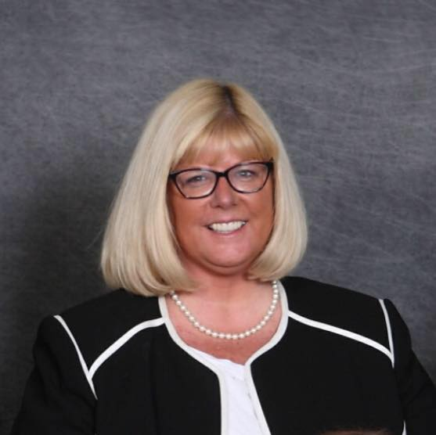
Warsaw, Indiana ─ The Cardinal Services Board of Directors has named Vickie Lootens as executive director, effective July 1, after accepting Matthew Boren’s decision to resign from the position.
“We’re thankful to Matt for all he has done to help Cardinal rebound from difficult times and prepare for a thriving future, and we wish him well,” said Cardinal Board Chair Anne Hill. “We are confident that Vickie’s deep love for Cardinal Services and its purpose make her an ideal choice as Cardinal’s next leader, building on the progress of the past year.”
Ongoing initiatives at Cardinal Services include creating new employment pathways for persons served; expanding and enhancing services, such as new behavior consulting services and club rooms in day services; and completing the Ability Campaign to support facility renovations.
“It has been an honor and a blessing to be part of the Cardinal story thus far,” Boren said. “I am confident the organization is moving in a healthy direction full of opportunities, and I look forward to seeing what the future brings.”
Lootens has been with Cardinal Services for more than 17 years, starting in employment services then shifting to the development team where she currently serves as chief development officer.
“I am honored to have the opportunity to lead Cardinal Services and build on the tremendous momentum of the past year,” Lootens said. “I look forward to being a part of the effort to bring Cardinal to the next level, making a positive difference for the people we serve, our employees, and our community.”
# # #
About Cardinal Services: Cardinal Services provides a full array of services to adults with intellectual disabilities and to families who have small children with needs. Since 1954, Cardinal has assisted and advocated for people with disabilities and challenges to live lives full of dignity, growth and opportunity. Cardinal’s purpose is to lead the way to full equity, access and inclusion for people with disabilities, families and communities. To learn more, visit www.cardinalservices.org.

